Bode plot of the DC motor system:

j=0.01;

b=0.1;

k=0.01;

r=1;

l=0.5;

a= [-b/j k/j ;-k/l -r/l]

b=[0 ; 1/l];

c=[1 0];

d=0;

[num,den]=ss2tf(a,b,c,d)

num=num(3);

bode(num,den)

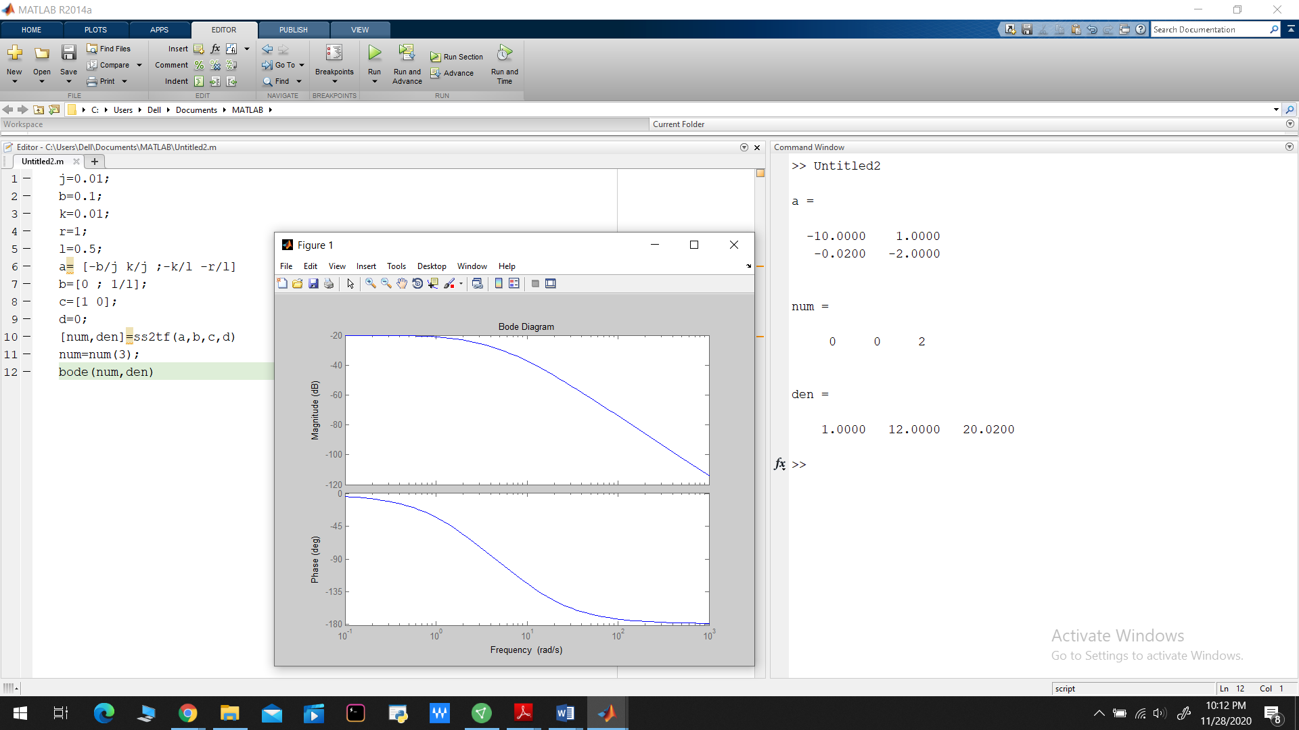

FOR PROPTIONAL GAIN:

j=0.01;

b=0.1;

k=0.01;

r=1;

l=0.5;

a= [-b/j k/j ;-k/l -r/l]

b=[0 ; 1/l];

c=[1 0];

d=0;

[num,den]=ss2tf(a,b,c,d)

num=num(3);

bode(num,den)

[mag,phase,w]= bode(num,den,10)

num =70\*num

figure(1)

[numc,denc]=cloop(num,den,-1);

t=0.:0.01:10;

step(numc,denc,t)

OUTPUT:

>> Untitled2

a =

-10.0000 1.0000

-0.0200 -2.0000

num =

0 0 2

den =

1.0000 12.0000 20.0200

mag =

0.0139

phase =

-123.6835

w =

10

num =

140

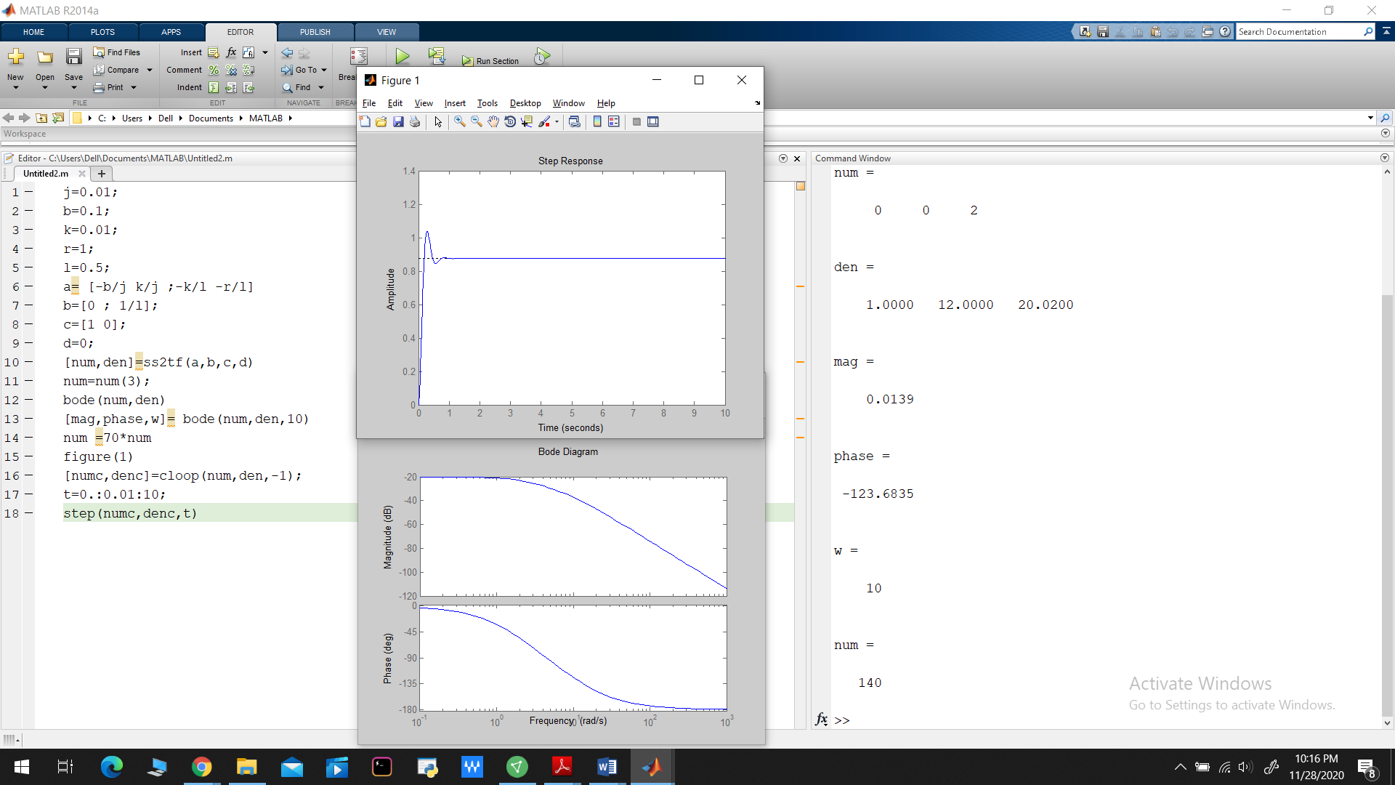

FOR THE LAG CONTROLLER:

j=0.01;

b=0.1;

k=0.01;

r=1;

l=0.5;

a= [-b/j k/j ;-k/l -r/l];

b=[0 ; 1/l];

c=[1 0];

d=0;

[num,den]= ss2tf(a,b,c,d);

num=50\*num(3);

z=1;

p=0.01;

numa=[1 z];

dena=[1 p];

numb=conv(num,numa)

denb=conv(den,dena)

bode(numb,denb)

figure

[numc,denc]=cloop(numb,denb,-1);

t=0.:0.01:10;

step(numc,denc,t)

